
TV App Episode Form
Episode Title: How to Sell Nonfiction Books in Bulk
Episode Download Link: Susan Friedmann How to Sell Non-Fiction Books in Bulk.mp4
Episode Image Download: Susan TN.png

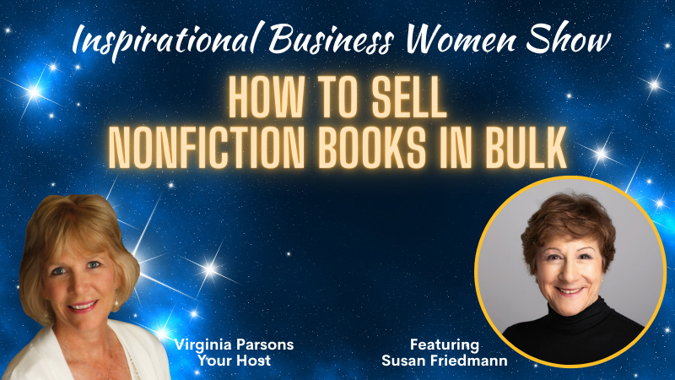
Short Description (250 max). Discover how to sell nonfiction books in bulk with powerhouse writer and publisher Susan Friedmann who has written 18 books and sold over 500,000 copies of her first book.

Tag: business strategy, marketing, sales, book
Desired Publish Date: 1/18/24 or as soon as you can get to it
Related URL: https://shinetips.com/susangift

Text: Susan’s Gift
Long Description: If you have been thinking about writing a non-fiction book and wondered about how to effectively market and sell that book, don’t miss my interview with Susan Friedmann. She has turned her 30+ years of experience into a mission to help solopreneurs stand out from the crowd. Susan has guided hundreds of non-fiction authors toward mastery in their niche. She's an absolute writing powerhouse, with 18 books to her name - the first selling more than 500,000 copies! She will reveal:

- How to find the right niche market for your book
- Simple steps to make money with your book
- Marketing mistakes many authors unknowingly make
When she's not changing the game for nonfiction authors, Susan is living life to the fullest. From being chased by an elephant to hugging a tiger, from teaching yoga to being rescued by the National Guard, enjoying 3 grandchildren, and traveling with her life partner of 53 years, her life is brimming with incredible experiences and accomplishments.
Join Us for How to Sell Nonfiction Books in Bulk and please help get the word out and share with those who may need a business boost.

Each #IBWS provides "a Goldmine of Entrepreneurial Tips, Strategies and Advice to grow your business to new Heights of Success from Inspirational Business Women in the Know.”

Hear the inspired stories and personal struggles of these amazing women and learn how they rose to the top of their field while making a big impact on the lives of others.

As your host, it is my deepest desire to uplift and inspire our "sister entrepreneurs" to pursue their dreams and share their passions with the world. Together we can "make a real difference" across the globe.

Please LIKE and SHARE this event with those who may benefit.

